TOPIC 11: Forensics

Worksheet 11.4

Mystery in the house
Answers
You are a forensic scientist within your own home. You have your forensic toolbox with you. Turn a room of your home into a crime scene and decide the type of crime that has been committed.
Design a crime scene investigator’s report that outlines the steps you would take to investigate the evidence in this room.
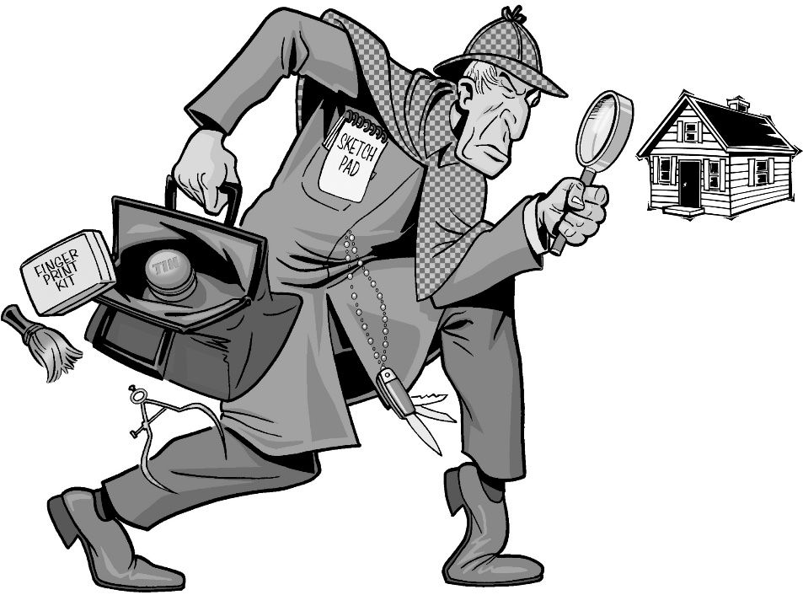
1. How would you seal off the room?
Close and lock doors and windows, post a look out.

2. How would you investigate what has happened in this room before you arrived?
Careful observation and measurement

3. Look around the room and write down anything that is unusual, for example, a chair in the wrong position or a glass left on a table. How would you record this evidence?
Photography, sketches

4. Look for some hair and fibre evidence from the room. How would you collect and identify the type of hair or fibre?
Tweezers and plastic sample bags, labelled containers

5. Look for any objects that may have fingerprint evidence. What objects have, or could produce, clear fingerprint evidence? How would you collect this evidence and identify the fingerprints?
Glass or metal surfaces, crockery, cutlery or cooking utensils, doorknobs, windows, mirrors etc.

6. Is there any evidence that you cannot see in the daylight? How would you identify this evidence?
Ultraviolet and infra-red lighting may detect blood, fingerprints or fibres.

